EXPERIMENT 22
ACQUISITION AND DIGITAL SIGNAL PROCESSING OF ECG, EEG AND EMG SIGNALS USING BIOMEDICAL SIGNAL ACQUISITION SYSTEMS
Lokesh A | Register No.: 192512293
B.E. Electronics and Communication Engineering (ECE)
Date of Experiment: 13 October 2026
1. AIM
To acquire or generate ECG, EEG and EMG signals, process them using digital filters in MATLAB, and analyse their time-domain waveforms, frequency spectra and characteristic parameters.
2. OBJECTIVES
- To obtain ECG, EEG and EMG signals from real datasets or reproducible synthetic signal models.
- To remove unwanted baseline drift, power-line interference and out-of-band noise using Butterworth band-pass filters.
- To apply a 50 Hz notch filter to the EMG signal to reduce mains interference.
- To plot raw and filtered signals and compare their magnitude spectra.
- To extract ECG R-peaks and heart rate, EEG relative band powers, and EMG RMS amplitude.
3. SOFTWARE AND REQUIREMENTS
Software: MATLAB with Signal Processing Toolbox. For real-signal operation, ECG, EEG and EMG data should be provided in MAT-files containing the variables ecg_raw, eeg_raw and emg_raw respectively. The supplied program can also generate synthetic signals for demonstration.
4. INPUT PARAMETERS
Parameter | Value | Purpose
ECG sampling frequency | 360 Hz | ECG acquisition
EEG sampling frequency | 256 Hz | EEG acquisition
EMG sampling frequency | 1000 Hz | EMG acquisition
ECG filter band | 0.5–40 Hz | Retain useful ECG components
EEG filter band | 1–40 Hz | Retain common EEG rhythms
EMG filter band | 20–450 Hz | Retain useful EMG components
Record duration | 10 s | Signal observation interval
Power-line frequency | 50 Hz | Mains-interference rejection
Butterworth order | 4 | Band-pass filter design
5. THEORY
Biomedical signals such as ECG, EEG and EMG are low-amplitude signals that can be contaminated by baseline drift, power-line interference, motion artefacts and broadband noise. Digital filtering helps retain the frequency components of interest while attenuating unwanted components.
A Butterworth band-pass filter provides a maximally flat passband. The ECG is filtered over 0.5–40 Hz, the EEG over 1–40 Hz, and the EMG over 20–450 Hz. The EMG signal is additionally processed by a 50 Hz notch filter. The MATLAB function filtfilt is used for zero-phase filtering, reducing phase distortion in the filtered waveform.
ECG analysis identifies R-peaks and calculates RR intervals. The mean heart rate is calculated using HR = 60 / mean(RR), where RR is measured in seconds. EEG band power is estimated from the power spectral density in delta (1–4 Hz), theta (4–8 Hz), alpha (8–13 Hz) and beta (13–30 Hz) bands. EMG activity is described using RMS amplitude: RMS = sqrt((1/N) sum(x[n]^2)).
6. PROCEDURE
- Set the sampling frequencies, filter bands, record duration and filter order.
- Load real signals from MAT-files or generate synthetic ECG, EEG and EMG signals.
- Design Butterworth band-pass filters and filter each signal using zero-phase filtering.
- Apply a 50 Hz notch filter to the filtered EMG signal.
- Compute the single-sided magnitude spectra of raw and filtered signals.
- Detect ECG R-peaks, calculate RR intervals and estimate heart rate.
- Estimate EEG power in delta, theta, alpha and beta frequency bands.
- Calculate the raw and filtered EMG RMS values and the moving RMS envelope.
- Display waveforms, spectra, filter responses and numerical output parameters.
7. MATLAB IMPLEMENTATION
The corrected MATLAB script is provided separately as Experiment_22_ECG_EEG_EMG_Corrected.m. It includes signal generation/loading, filtering, feature extraction, plotting and output-table generation. Set useRealData = true and provide the required MAT-files to process real recordings; otherwise, useRealData = false to run the synthetic demonstration.
8. RESULTS AND OBSERVATIONS
The MATLAB run completed the ECG, EEG and EMG filtering and feature-extraction stages. The following values were displayed in the supplied Command Window screenshot for the synthetic-signal run.
Parameter | Recorded value | Observation
Number of ECG R-peaks | 12 | R-peaks detected
Mean RR interval | 0.820 s | Average interval between successive peaks
Mean heart rate | 73.2 beats/min | Calculated from mean RR interval
Heart-rate range | 69.0–75.3 beats/min | Range of detected instantaneous values
Dominant EEG rhythm | Alpha | Largest relative power among the four evaluated bands
Delta relative power | 16.4% | 1–4 Hz
Theta relative power | 7.3% | 4–8 Hz
Alpha relative power | 71.7% | 8–13 Hz
Beta relative power | 4.6% | 13–30 Hz
EMG RMS (raw) | 0.3228 mV | Before filtering
EMG RMS (filtered) | 0.2305 mV | After filtering
Peak EMG RMS envelope | 0.5219 mV | 100 ms moving RMS
ECG SNR (raw → filtered) | -4.55 → 7.59 dB | Synthetic reference comparison
EEG SNR (raw → filtered) | -2.84 → 14.04 dB | Synthetic reference comparison
EMG SNR (raw → filtered) | 0.35 → 21.52 dB | Synthetic reference comparison
The screenshots show raw and filtered waveforms, raw and filtered magnitude spectra, ECG R-peak markers, instantaneous heart rate, EEG relative band power, EMG RMS envelope and the frequency responses of the three band-pass filters. The reported SNR values are from the synthetic-data validation section of the program; they should not be treated as clinical measurements.
9. FIGURES
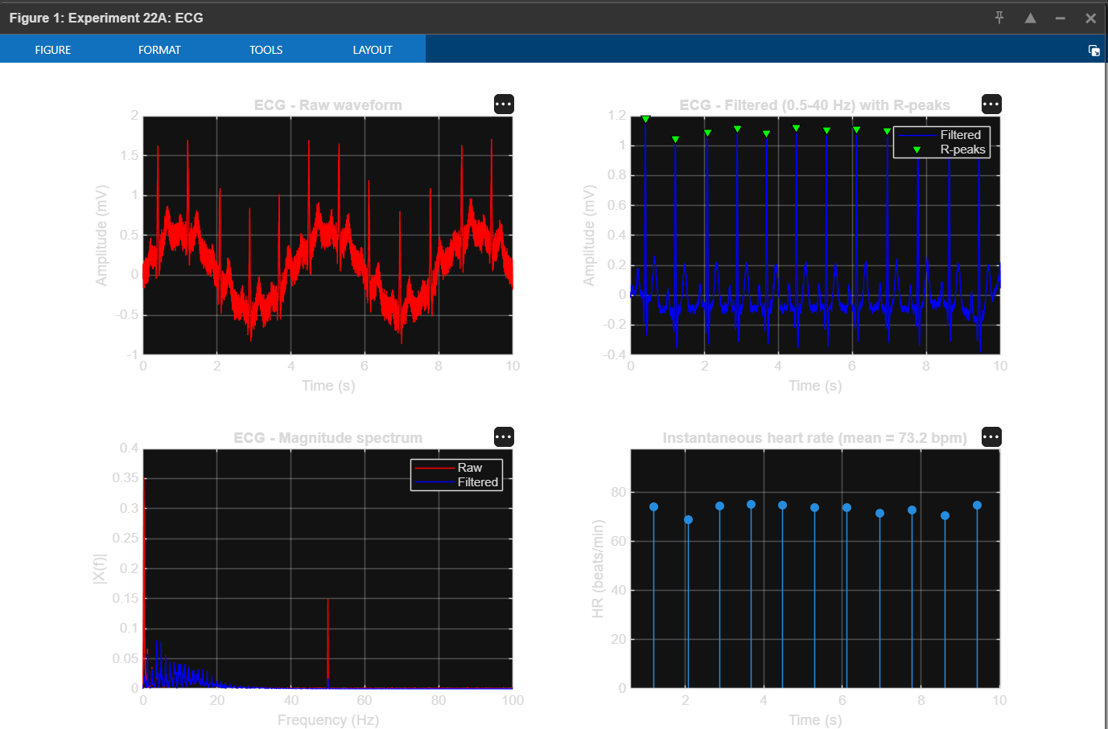
Figure 1. ECG raw and filtered waveforms, magnitude spectrum, and instantaneous heart rate.
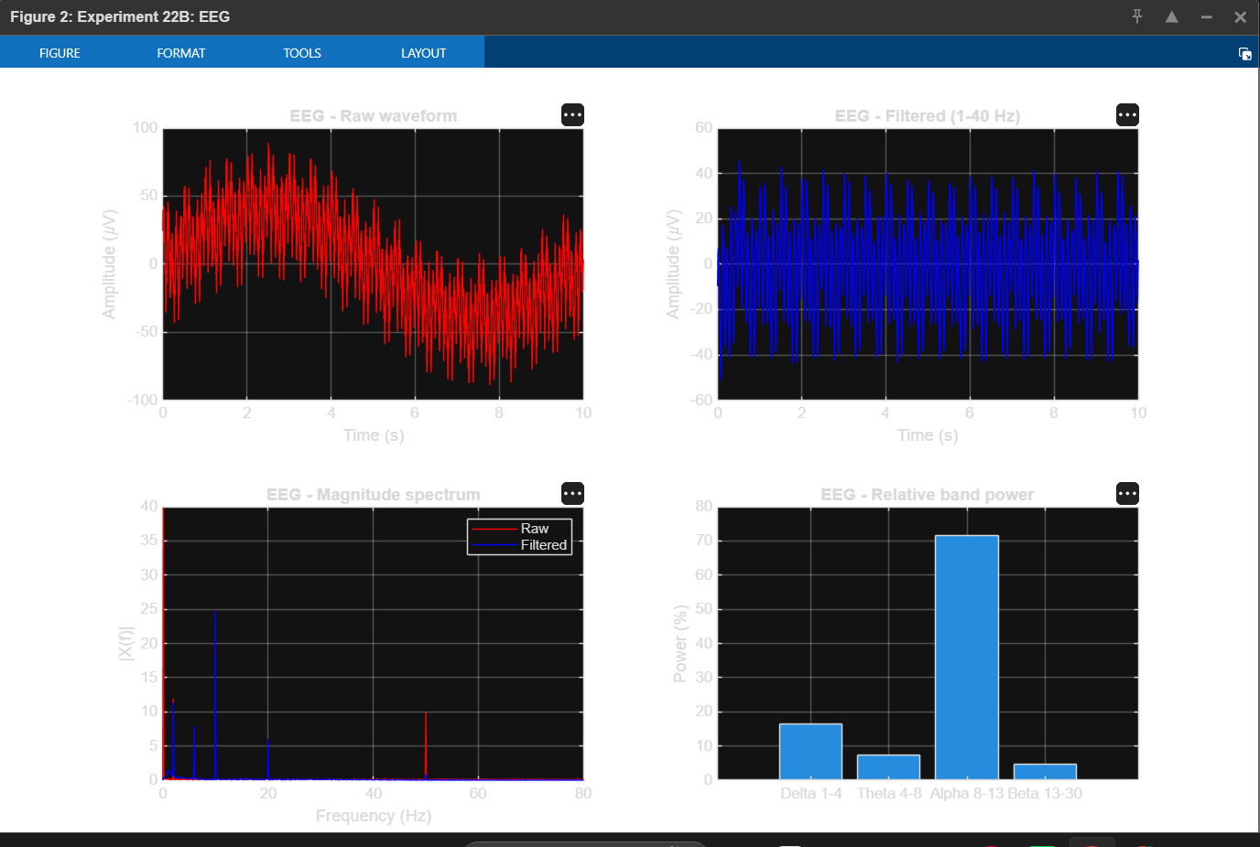
Figure 2. EEG raw and filtered waveforms, magnitude spectrum, and relative band power.
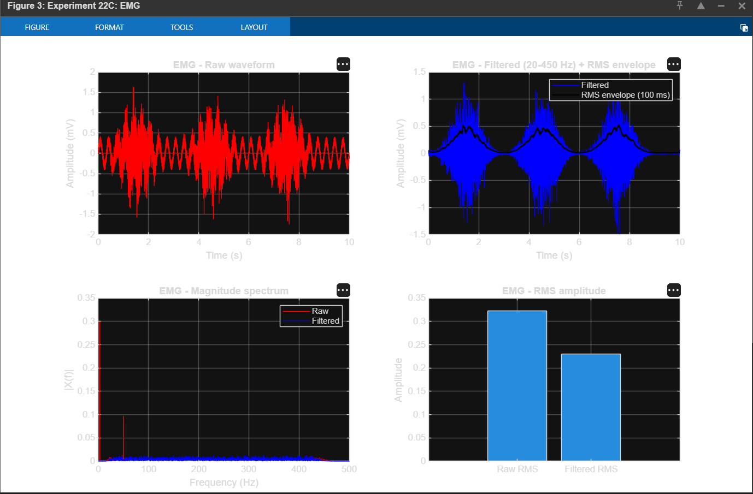
Figure 3. EMG raw and filtered waveforms, RMS envelope, magnitude spectrum, and RMS comparison.
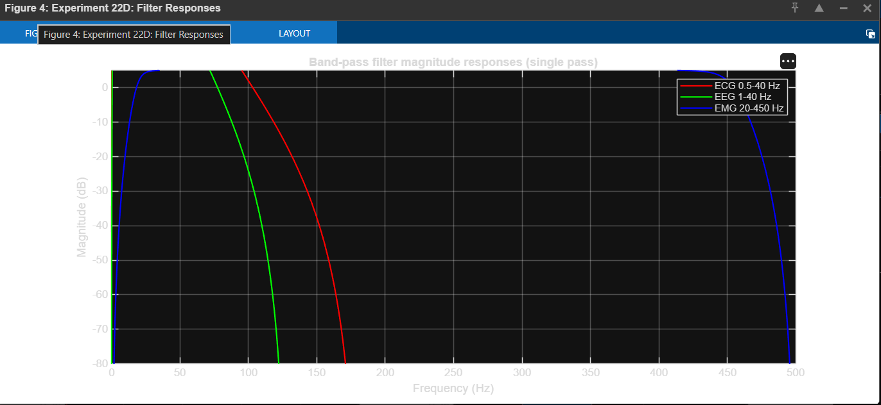
Figure 4. Magnitude responses of ECG, EEG and EMG band-pass filters.
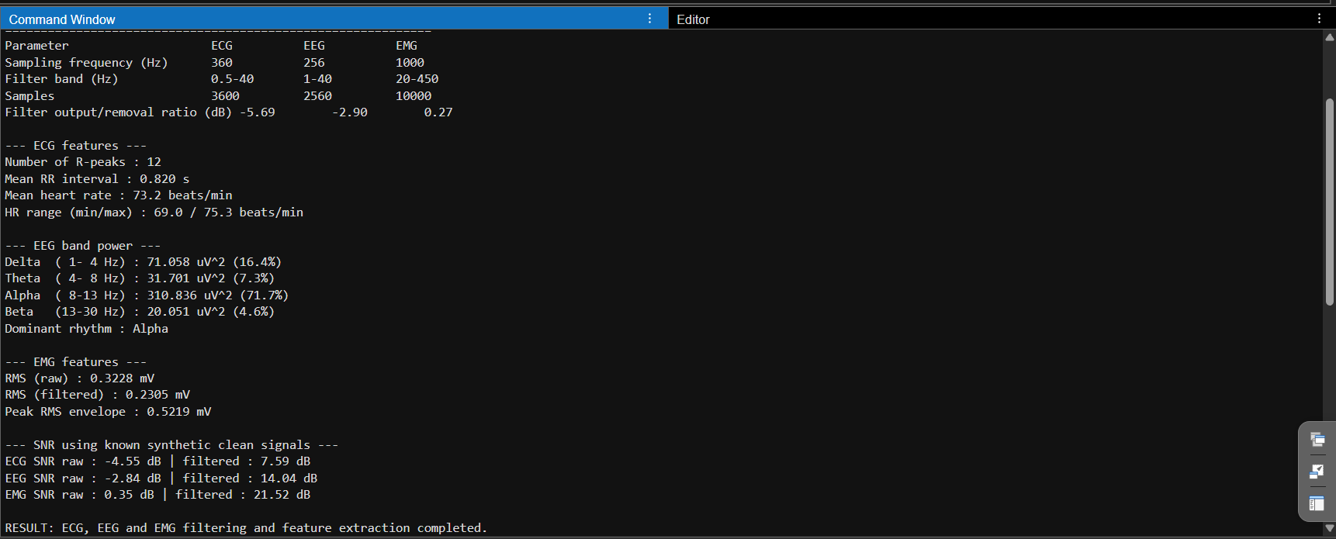
Figure 5. MATLAB Command Window output showing the recorded parameter values and extracted features.
10. CONCLUSION
ECG, EEG and EMG signals were processed in MATLAB using Butterworth band-pass filtering, with additional 50 Hz notch filtering for EMG. The program generated time-domain and frequency-domain plots and extracted ECG heart-rate features, EEG band-power values and EMG RMS measurements. The displayed results demonstrate the use of digital signal processing techniques for biomedical signal analysis. Real clinical interpretation requires validated acquisition hardware, suitable datasets and qualified medical review.
11. PRECAUTIONS
- Use the correct sampling frequency for each signal and ensure the selected filter cut-off frequencies are below the Nyquist frequency.
- Check that real-data MAT-files contain the expected variable names and enough samples.
- Synthetic signals are for software demonstration only and are not substitutes for clinical recordings.
- Do not interpret the program output as a medical diagnosis.

